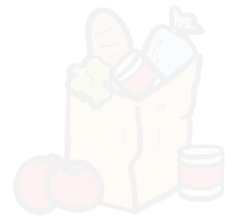
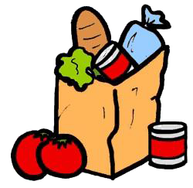
Grocery List Template
Important Notes: _______________________________________________________________ __________________________________________________________________________________________________________________________________________________________________________________________________________________________________________
Misc.
Item Names | Quantity

Produce
Item Name | Quantity

Vegetables
Item Name | Quantity

Cleaning Products
Item Name | Quantity

Meats
Item Name | Quantity

Frozen Food Items
Item Name | Quantity

Canned/Dry
Item Name | Quantity

Dairy Products
Item Name | Quantity

Grocery List

